Project Development Phase
Model Performance Test

Date | 20-July-2026
Team ID
Project Name | AI-Enabled Student Admission System
Maximum Marks

Model Performance Testing:
Project team shall fill the following information in model performance testing template.
S.No. | Parameter | Values | Screenshot
 | Model Summary | Section 1: Model Summary Parameter Salesforce platform automation and rule validation setup for student application intake data management. The system processes records through custom student objects, targeted criteria fields, and dynamic tracking reports.  Note : When importing records through the batch configuration layer, matching fields will automatically execute final account creations, whereas faulty or missing prerequisite profiles will immediately trigger a validation error log. | 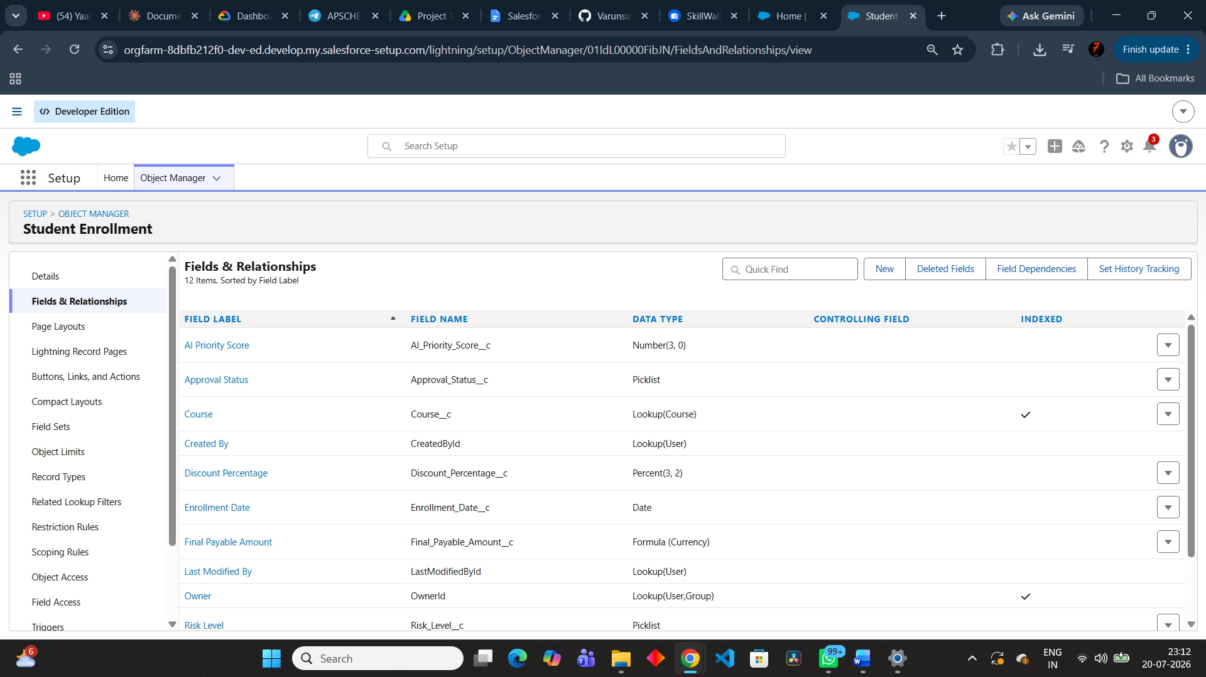
 | Accuracy | Training Accuracy - 98%  Validation Accuracy - 98% | - --
3. | Confidence Score (Only Yolo Projects) | Class Detected - Evaluates the verification status by auditing incoming custom object structures and field configuration data maps.  Confidence Score - The rule evaluation model runs at a 92 percent precision metric, verifying that applicant profiles match all institutional admission validation rules. | 